# Geospacial Document DB Query

* Open the Azure portal and login ([portal.azure.com](https://portal.azure.com))
* Navigate to the “DocumentDB Accounts” and select the provisioned account
* 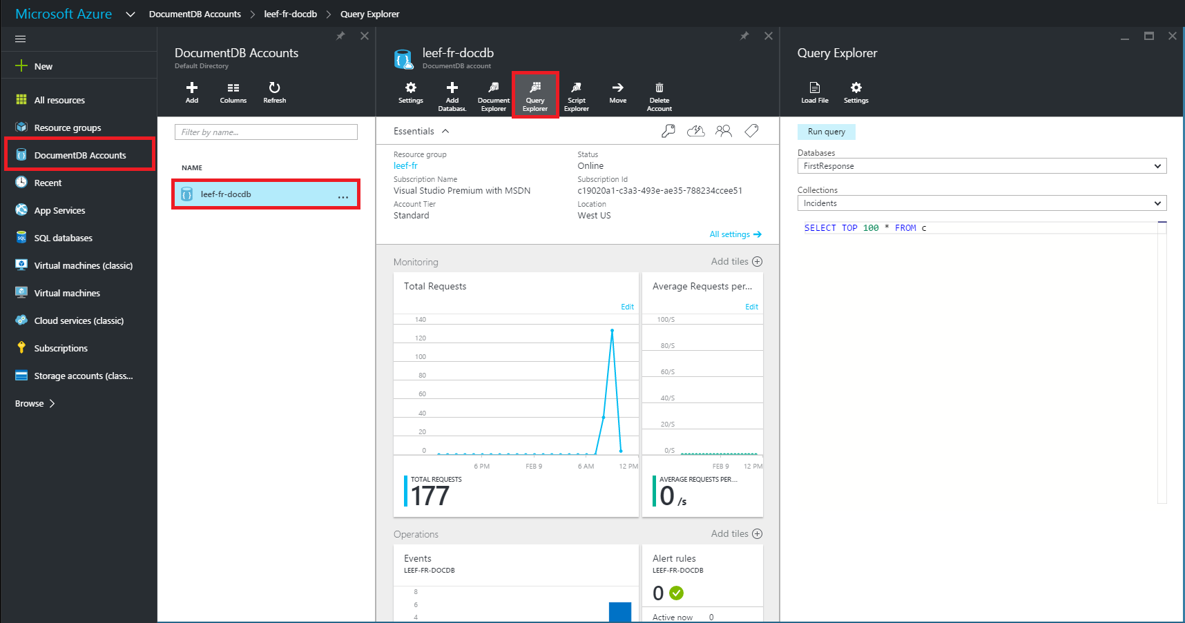Press on the “Query Explorer” button in the top of the account window

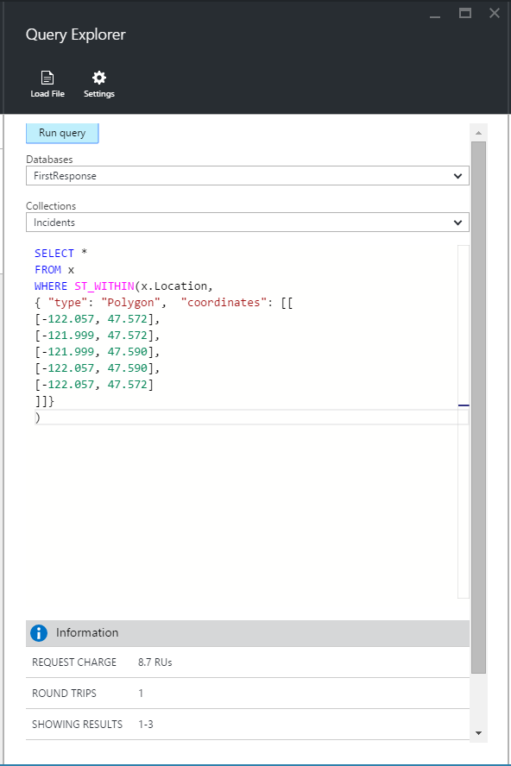

* In the query explorer enter the following query:

SELECT *

FROM x

WHERE ST_WITHIN(x.Location,

{ "type": "Polygon", "coordinates": [[

[-122.057, 47.572],

[-121.999, 47.572],

[-121.999, 47.590],

[-122.057, 47.590],

[-122.057, 47.572]

]]})

* Press the “Run Query” button at the top of the query explorer
* A new window will open with results from the polygon